SOROTI DISTRICT LOCAL GOVERNMENT
COMMUNICATION UNIT/SECTOR
DISTRICT PRODUCTION OFFICER
SOROTI

RE: REPORT ON RADIO TALK SHOW ON UGIFT MICROSCALE IRRIGATION PROGRAM ON VOICE OF TESO 88.4FM RADIO ON 20TH JUNE 2023
Topic
TOPIC MICRO -SCALE IRRIGATION PROGRAM
Introduction
The Micro-scale Irrigation Program supports farmers to purchase and use individual irrigation equipment. The Program supports farmers in purchasing the irrigation equipment through a matching grant scheme, in which the cost of the equipment is co-financed by the farmer and the government.
The goal
Awareness raising through Radio on Micro-scale Irrigation Program is in line with Uganda’s National Irrigation Policy which aims to create 1.5 million hectares of irrigated land by the year 2040.

PANELISTS:
SNO | NAME | TITLE | CONTACT
 | Kasonzi Martin Basalirwa | Deputy RDC SOROTI | 0772348931
 | Okello Moses Echeku | DAO Soroti DLG | 0774787322
 | Ekwaru Abraham | Communication Officer Soroti DLG | 0784883140
 | Atubu Robert (DJ ROBERTO | Radio Host- Voice of Teso (The people’s Choice 88.4Fm | 0783360169

The Radio talk-show was conducted on Tuesday, 20th of June 2023 from 8.00pm -9.00pm.
KEY TOPIC | KEY AREAS OF FOCUS | REMARK
MICRO -SCALE IRRIGATION PROGRAM | - An overview of Micro scale Irrigation.  - The program funds awareness-raising activities that help farmers understand how irrigation can improve productivity and help them earn a decent income.  - The Micro-scale Irrigation Program will help farmers buy irrigation equipment at a lower cost, teach them how to use the irrigation equipment and when and how to water their crops | Handled
IRRIGATION EQUIPMENT SUPPLIERS | - LGs will be procuring the irrigation equipment after farmers’ successful application to the program. | Handled
FINANCIAL INSTITUTIONS | - As farmers will need to finance part of the irrigation equipment, they might need to access loans to provide their contribution. | Handled
VALUE CHAIN ACTORS | - With higher and more diversified production, farmers will need to better commercialize their produce. | Handled

METHOD USED:
It delivered through panelists articulating the message to the audience and time was allocated to the audience to ask questions and responses given by panelists.
OUTCOME:
The radio talk shows went on successfully and following realized;
- Publicity for the program to popularize it
- Farmers were sensitized on the benefit irrigation
- Farmers sensitized on good farming practices
- Farmers briefed on requirements to benefit from the project
- A number of farmers expressed interest after interaction with panelist
- Farmers as the target audience were able to understand the four core objectives of the of the UgIFT Microscale Irrigation Program
- Finally, the Public was informed on the stages involved in the UgIFT Microscale Irrigation Program implementation.
CHALLENGES:
The budget provided for an hour per radio talk show which did not give enough time to engage the audience.
RECOMMENDATIONS:
More resources should be allocated for radio talk shows so as to have enough time to engage the audience
CONCLUSION:
The talk show has opened the minds of most farmers most of them for appreciated the impact publicity thus increased number of people who expressed interest in the program.
Prepared by:
Ekwaru Abraham, Communication Officer
Appendix
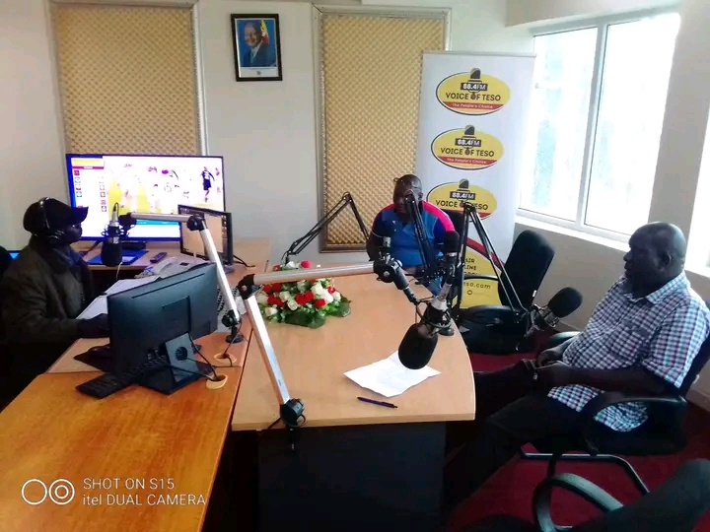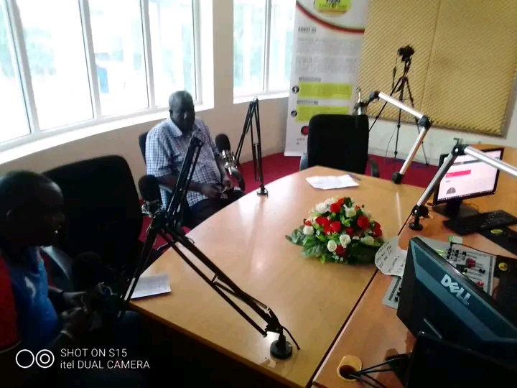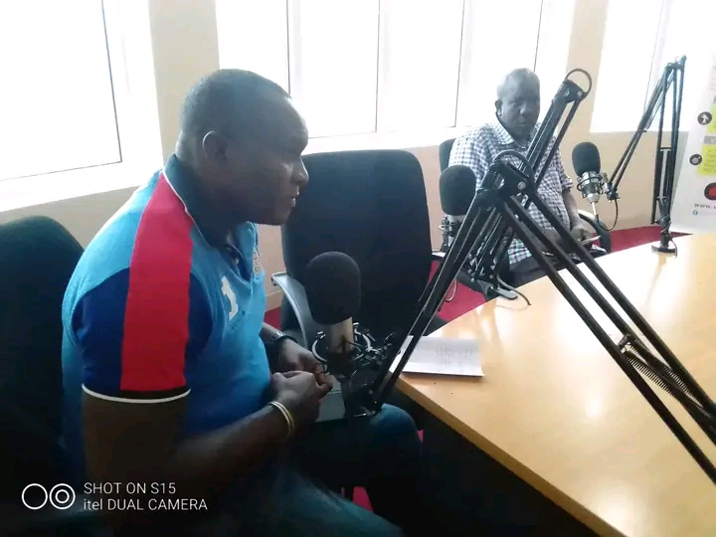
Figure 1: Deputy RDC, Kansozi Martin, DAO Okello Moses Eceku, Ekwaru Abrahma CO, during one the radio talkshow held on 20 June, 2023

SOROTI DISTRICT LOAL GOVERNMENT
COMMUNICATION UNIT/SECTOR
DISTRICT PRODUCTION OFFICER
SOROTI

RE: REPORT ON RADIO TALK SHOW ON UGIFT MICROSCALE IRRIGATION PROGRAM ON DELTA RADIO ON 23RD MAY, 2023
Topic
TOPIC MICRO -SCALE IRRIGATION PROGRAM
Introduction
The Micro-scale Irrigation Program supports farmers to purchase and use individual irrigation equipment. The Program supports farmers in purchasing the irrigation equipment through a matching grant scheme, in which the cost of the equipment is co-financed by the farmer and the government.
The goal
Awareness raising through Radio on Micro-scale Irrigation Program is in line with Uganda’s National Irrigation Policy which aims to create 1.5 million hectares of irrigated land by the year 2040.

PANELISTS:
SNO | NAME | TITLE | CONTACT
 | Okello Moses Echeku | District Agriculture Officer Soroti DLG | 0774787322
 | Ekwaru Abraham | Communication Officer Soroti DLG | 0784883140
 | Olila John | Moderator/Presenter- Host talkshow | 0789279075

The Radio talk-show was conducted on Tuesday, 23rd May, 2023 from 7.00pm -8.00pm.
KEY TOPIC | KEY AREAS OF FOCUS | REMARK
MICRO -SCALE IRRIGATION PROGRAM | - An overview of Micro scale Irrigation.  - The program funds awareness-raising activities that help farmers understand how irrigation can improve productivity and help them earn a decent income.  - The Micro-scale Irrigation Program will help farmers buy irrigation equipment at a lower cost, teach them how to use the irrigation equipment and when and how to water their crops | Handled
IRRIGATION EQUIPMENT SUPPLIERS | - LGs will be procuring the irrigation equipment after farmers’ successful application to the program. | Handled
FINANCIAL INSTITUTIONS | - As farmers will need to finance part of the irrigation equipment, they might need to access loans to provide their contribution. | Handled
VALUE CHAIN ACTORS | - With higher and more diversified production, farmers will need to better commercialize their produce. | Handled

METHOD USED:
It delivered through panelists articulating the message to the audience and time was allocated to the audience to ask questions and responses given by panelists.
OUTCOME:
The radio talk shows went on successfully and following realized;
- Publicity for the program to popularize it
- Farmers were sensitized on the benefit irrigation
- They were sensitized on good farming practices
- They were briefed on requirements to benefit from the project
- A number of farmers expressed interest after interaction with panelist
- Farmers as the target audience were able to understand the four core objectives of the of the UgIFT Microscale Irrigation Program
- Finally, the Public was informed on the stages involved in the UgIFT Microscale Irrigation Program implementation.
CHALLENGES:
The budget provided for an hour per radio talk show which did not give enough time to engage the audience.
RECOMMENDATIONS:
More resources should be allocated for radio talk shows so as to have enough time to engage the audience
CONCLUSION:
The talk show has opened the minds of most farmers most of them for appreciated the impact publicity thus increased number of people who expressed interest in the program.
Prepared by Ekwaru Abraham,
Communication Officer

Appendix
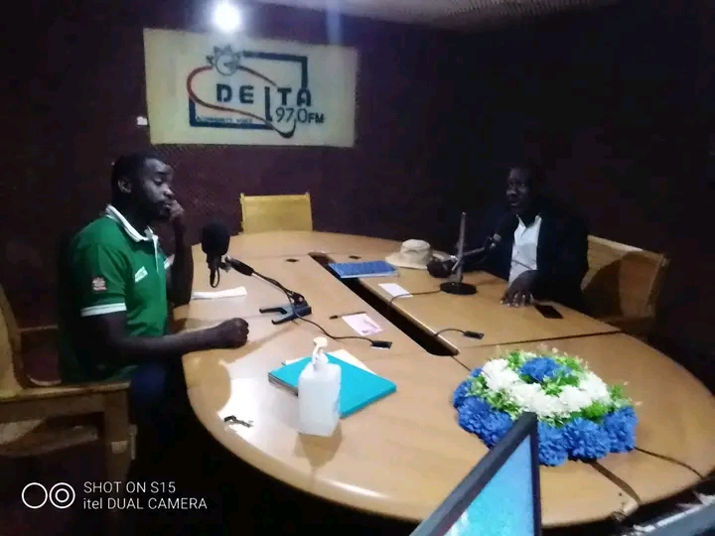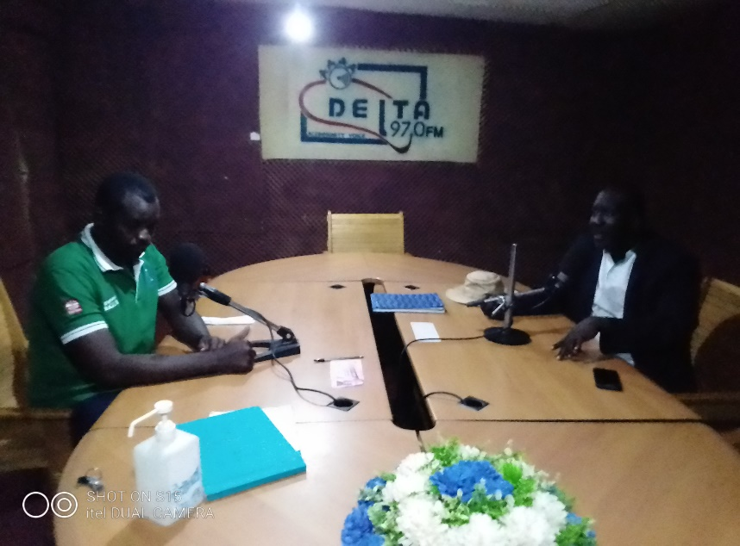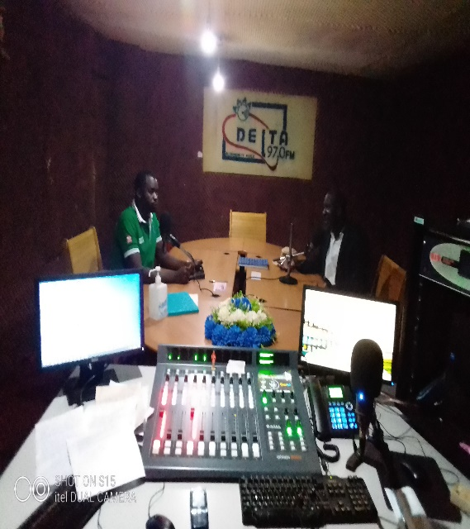

Figure: District Agriculture Officer, Mr Okello Moses Echeku, and Ekwaru Abraham, the Communication Officer, having a radio talkshow on Delta Radio.

SOROTI DISTRICT LOCAL GOVERNMENT
COMMUNICATION UNIT/SECTOR
DISTRICT PRODUCTION OFFICER
SOROTI

RE: REPORT ON RADIO TALK SHOW ON UGIFT MICROSCALE IRRIGATION PROGRAM ON ETOP RADIO 99.4FM ON 11TH MAY, 2023
Topic
TOPIC MICRO -SCALE IRRIGATION PROGRAM
Introduction
The Micro-scale Irrigation Program supports farmers to purchase and use individual irrigation equipment. The Program supports farmers in purchasing the irrigation equipment through a matching grant scheme, in which the cost of the equipment is co-financed by the farmer and the government.
The goal
Awareness raising through Radio on Micro-scale Irrigation Program is in line with Uganda’s National Irrigation Policy which aims to create 1.5 million hectares of irrigated land by the year 2040.

PANELISTS:
SNO | NAME | TITLE | CONTACT
 | Kumakech Salim | RDC SOROTI | 0772348931
 | Okello Moses Echeku | DAO Soroti DLG | 0774787322
 | Ekwaru Abraham | Communication Officer Soroti DLG | 0784883140
 | Oluk Patrick | Radio Host | 0783360169

The Radio talk-show was conducted on Thursday, 11th of May 2023 from 7.00pm -8.00pm.
KEY TOPIC | KEY AREAS OF FOCUS | REMARK
MICRO -SCALE IRRIGATION PROGRAM | - An overview of Micro scale Irrigation.  - The program funds awareness-raising activities that help farmers understand how irrigation can improve productivity and help them earn a decent income.  - The Micro-scale Irrigation Program will help farmers buy irrigation equipment at a lower cost, teach them how to use the irrigation equipment and when and how to water their crops | Handled
IRRIGATION EQUIPMENT SUPPLIERS | - LGs will be procuring the irrigation equipment after farmers’ successful application to the program. | Handled
FINANCIAL INSTITUTIONS | - As farmers will need to finance part of the irrigation equipment, they might need to access loans to provide their contribution. | Handled
VALUE CHAIN ACTORS | - With higher and more diversified production, farmers will need to better commercialize their produce. | Handled

METHOD USED:
It delivered through panelists articulating the message to the audience and time was allocated to the audience to ask questions and responses given by panelists.
OUTCOME:
The radio talk shows went on successfully and following realized;
- Publicity for the program to popularize it
- Farmers were sensitized on the benefit irrigation
- Farmers sensitized on good farming practices
- Farmers briefed on requirements to benefit from the project
- A number of farmers expressed interest after interaction with panelist
- Farmers as the target audience were able to understand the four core objectives of the of the UgIFT Microscale Irrigation Program
CHALLENGES:
The budget provided for an hour per radio talk show which did not give enough time to engage the audience.
RECOMMENDATIONS:
More time be secured so that the community gets adequate information
CONCLUSION:
The talk show has opened the minds of most farmers most of them for appreciated the impact publicity thus increased number of people who expressed interest in the program.
Prepared by:
Ekwaru Abraham, Communication Officer

Appendix
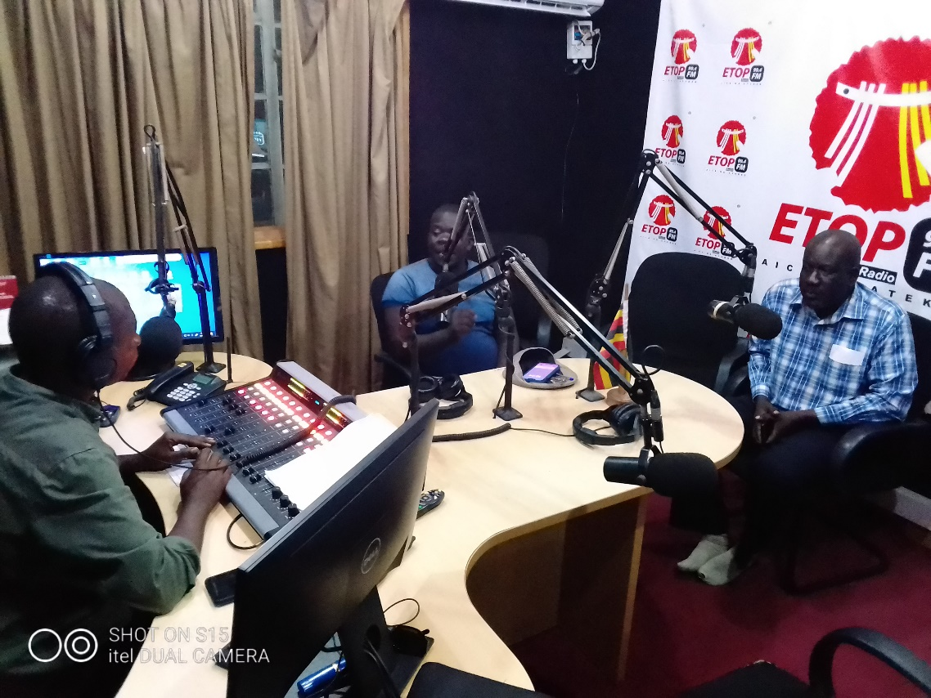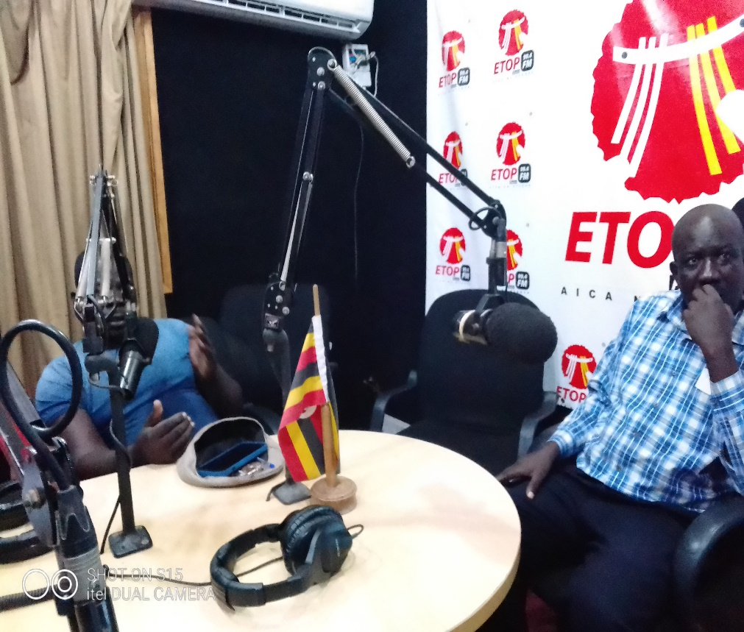
Figure: RDC Soroti district Mr Kumakech Salim, and District Agriculture Officer, Mr Okello Moses Echeku, having a radio talkshow on Etop radio radio, on 11th May, 2023, hosted by Patrick Oluk

